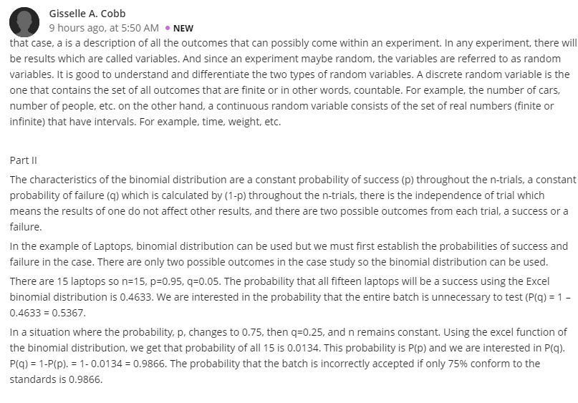
Reply 1
Hello Cobb
When undertaking experiment, it is critical to have sound knowledge in regards to variables. Actually, I found your study beneficial to researchers because you have brought significant clarity, more notably, discrete variable and continuous variable which are the possible outcomes for every random experiment. Clearly, discrete variable enables the researcher to have finite results while continuous variable allows the researcher to obtain infinite results as the way you have described them. Binomial distribution characteristics are also vital in carrying out an experiment and the researcher should ensure that he/she exploit this concept, particularly, in accepting or rejecting a certain project. Obviously, there are two possible outcomes from each trial, that is, a success or a failure as far as the independence of each trial is concerned. Indeed, your example on laptops has vividly elaborated the idea through calculations and in this case the probability that the laptops will be of success or fail in conforming the set standards which tend to have minimal success. Without a doubt, your study is pivotal to the business world to decide on a viable project which will realize significant profits when executed.
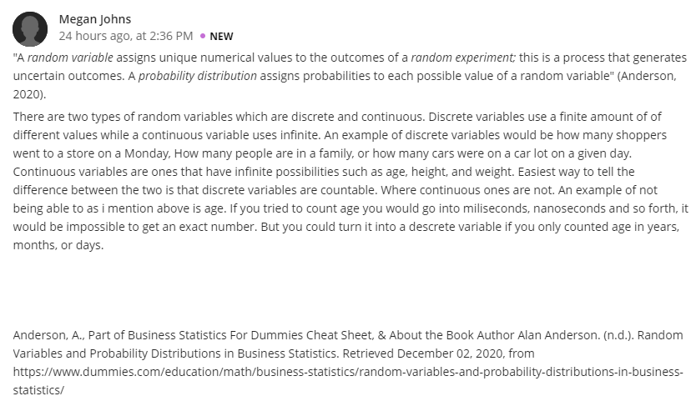
Reply 2
Hello johns
A random variable has become the topic of the day making me feel motivated to perform an experiment. I agree that a random variable attributes distinct numerical values to the results, especially the random experiments and on the other hand, probability distribution focuses on the probabilities of each trial. Simply, an outcome that is countable is considered as discrete variable like the number of students in a school. Contrastingly, an outcome that you cannot assign exact numerical value is regarded as continuous variable, for instance, you cannot attribute the exact number of age. Personally, this study is a important to achieve a successful experiment.

